Computer Networks Lab Week 7

Yashi Chawla

PES1UG19CS592

**Task 1: Assign IP addresses to all computers A, B, C, D (Source host HA, Router R1, Router R2 and Destination Host HD)**

**Step1: Assign the IP addresses to Ha**

Sudo ip addr add 172.16.10.1/24 dev eth1

Ip addr show

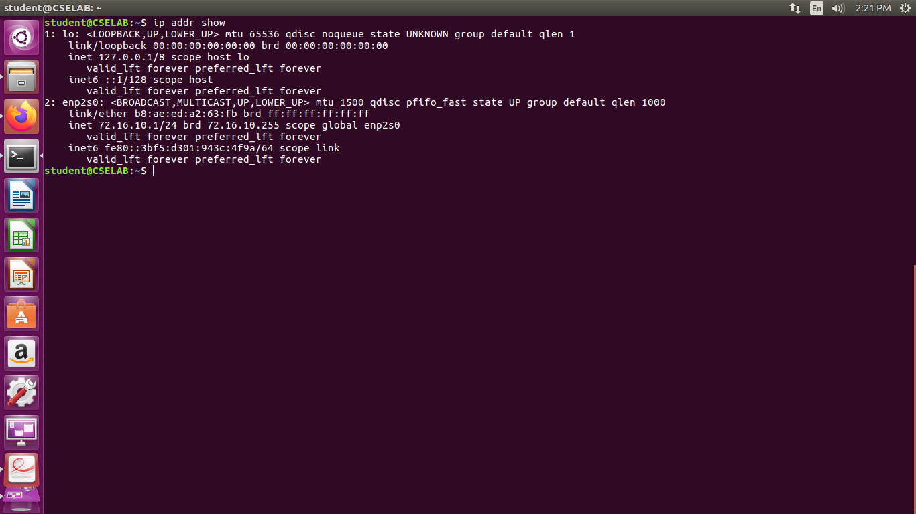

**Step 2: Assign the IP address to R1**

Sudo ip addr add 172.16.10.201/24 dev eth1

Sudo ip addr add 172.16.11.1/24 dev eth2

Ip addr show

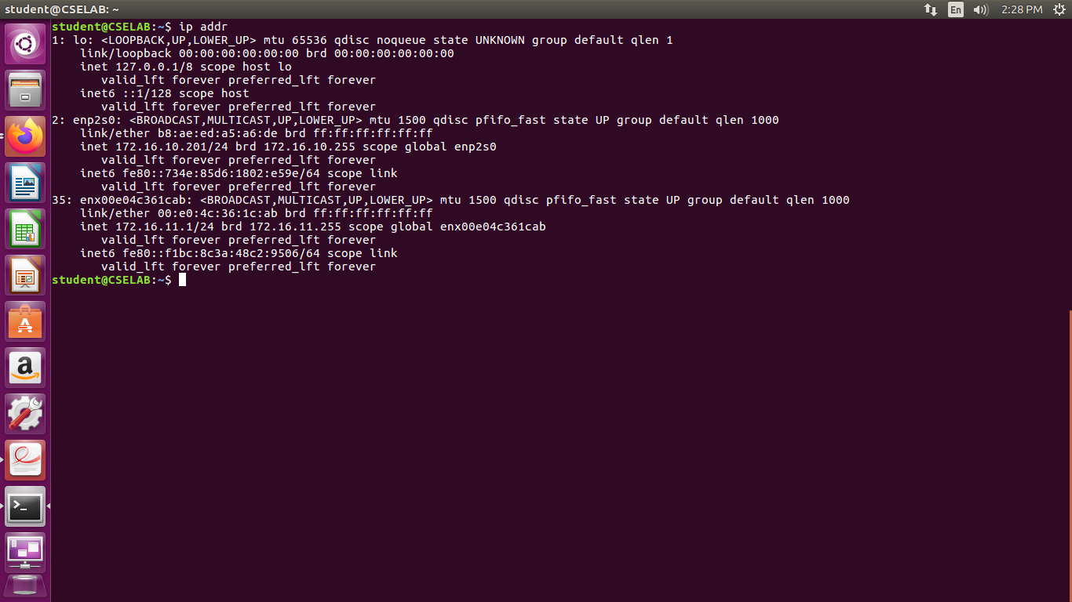

**Step 3: Assign the IP address to R2**

Sudo ip addr add 172.16.11.201/24 dev eth2

Sudo ip addr add 172.16.12.1/24 dev eth1

Ip addr show

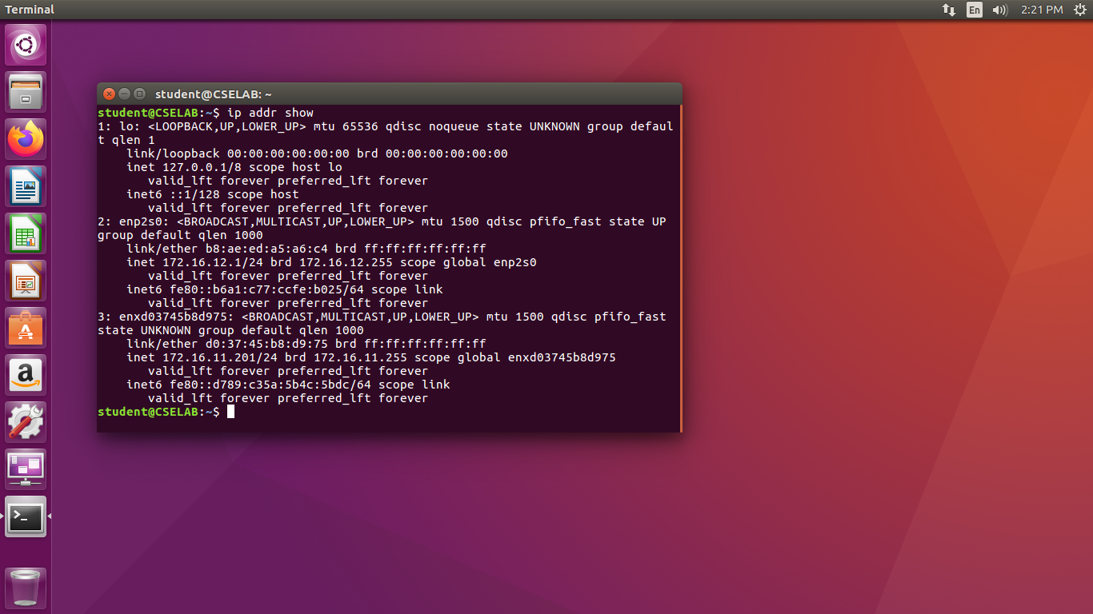

**Step 4: Assign the IP address to the Hd**

Sudo ip addr add 172.16.12.201/24 dev eth1

Ip addr show

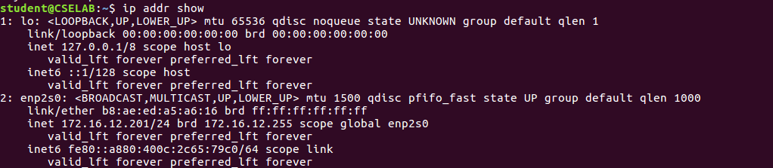

**Note 1: Disable accepting the ICMP redirect packets.**

Sudo sysctl -w net.ipv4.conf.all.accept_redirects=0

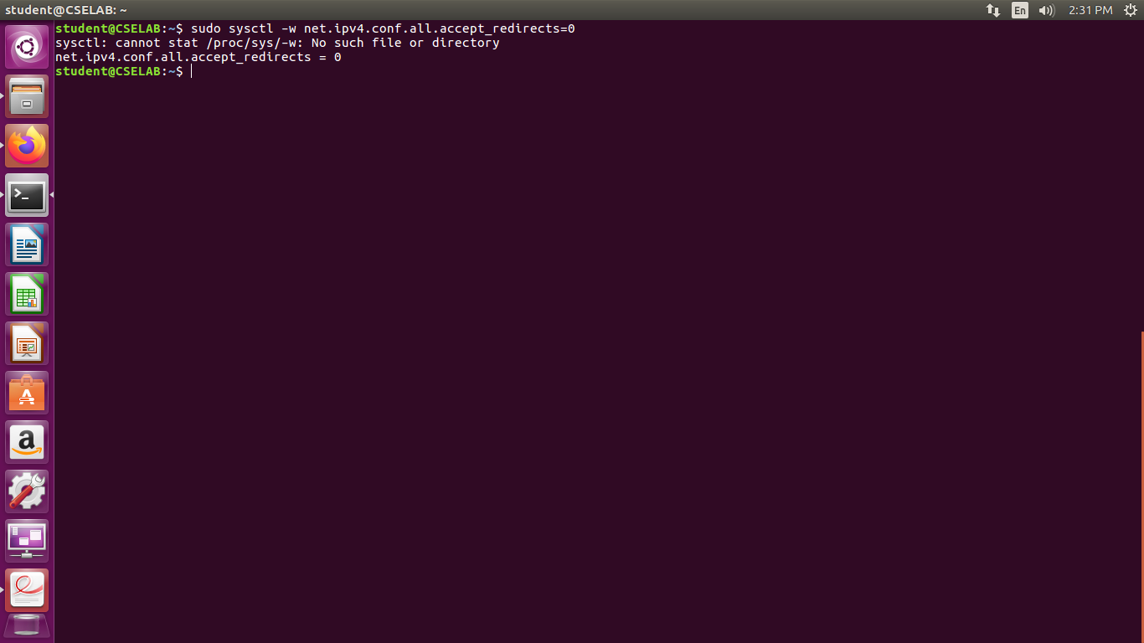



**Note 2: Disable sending of the ICMP redirect message.**

Sudo sysctl -w net.ipv4.conf.all.send_redirects=0

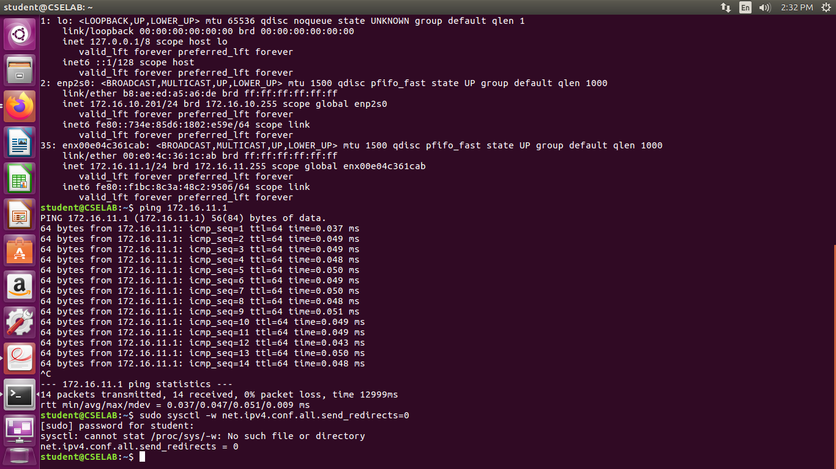

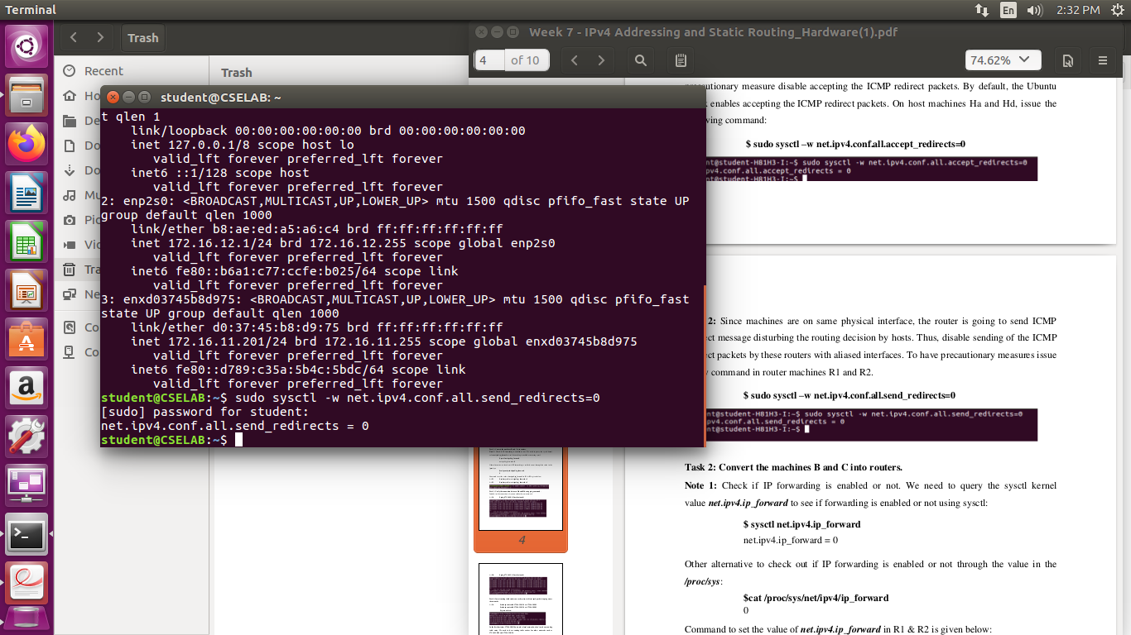

**Task 2: Convert the machines B and C into routers**

* Checking if IP forwarding is enables or not.

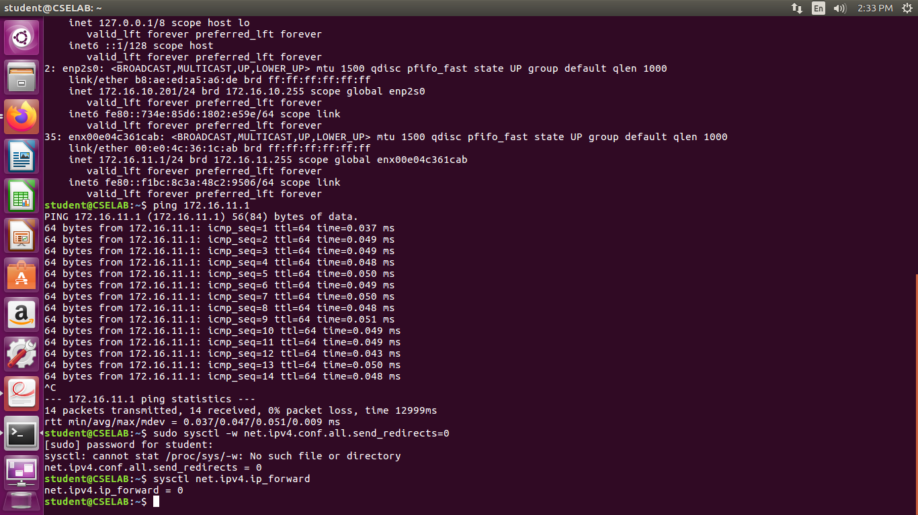

At R1: sudo sysctl -w net.ipv4.ip_forward=1

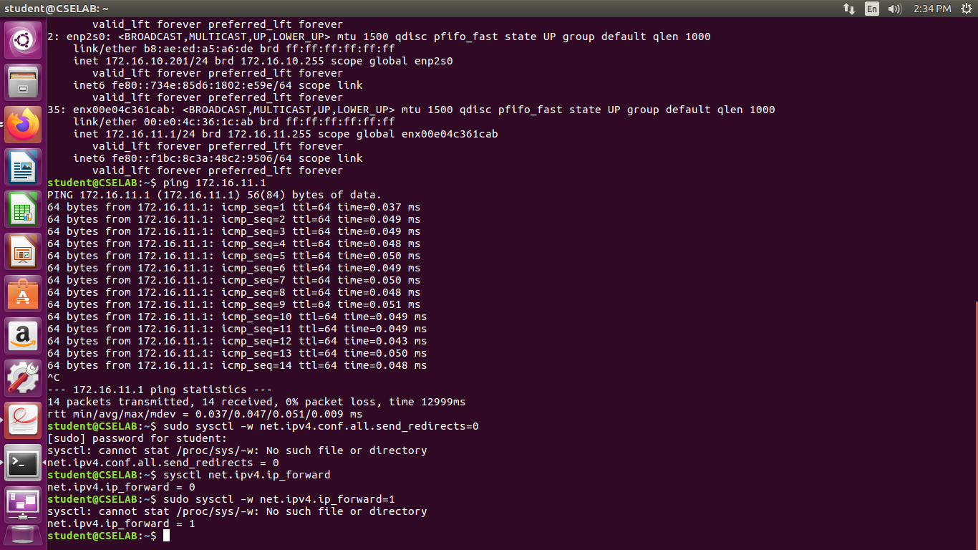

At R2: sudo sysctl -w net.ipv4.ip_forward=1

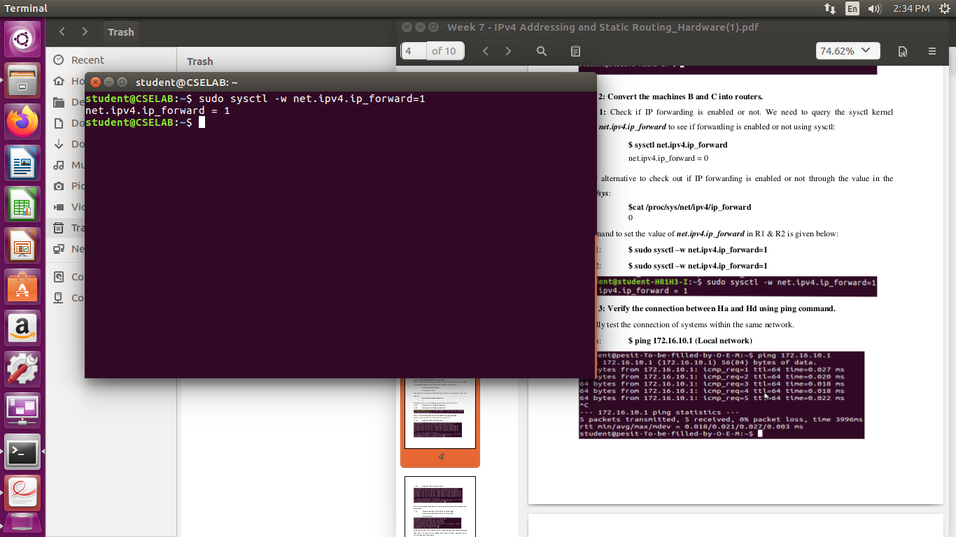

**Task 3: Verify the connection between Ha and Hd using ping command**

At Ha: ping 172.16.10.1(local network)

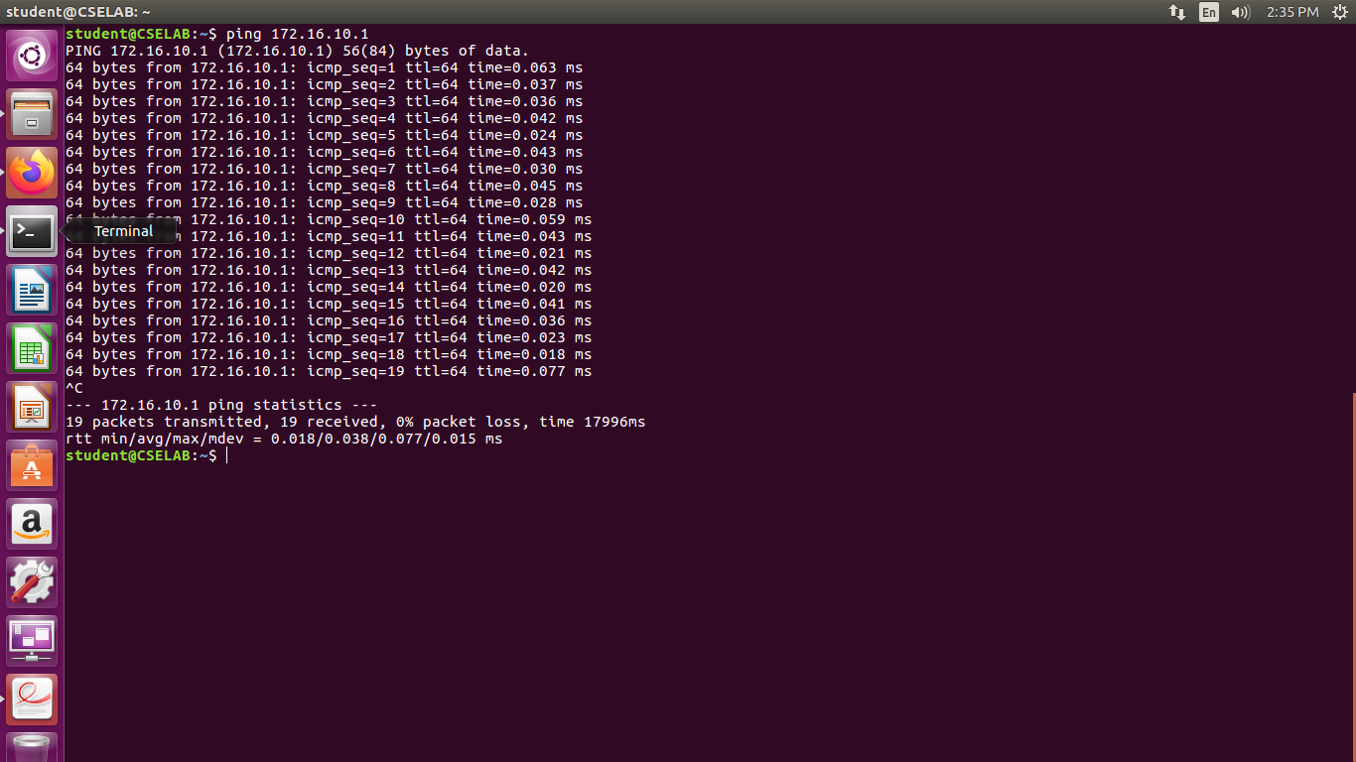

At Hd: ping 172.16.12.1(local network)

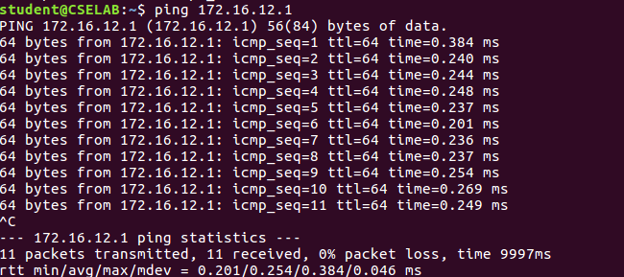

**Task 4: insert routing table entries on each system to direct ipv4 packets to ping across the networks.**

**At Ha:**

sudo ip route add 172.16.12.0/24 via 172.16.10.201

Sudo ip route add 172.12.11.0/24 via 172.16.10.201

Ip route show

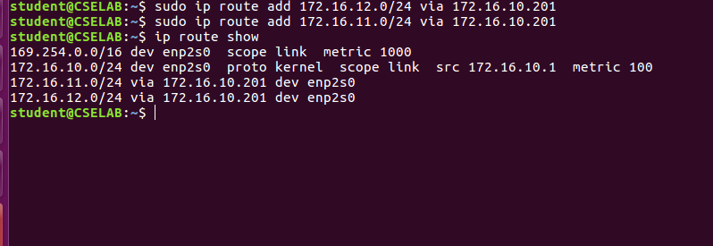

**At R1:**

Sudo ip route add 172.16.12.0/24 via 172.16.11.201

Ip route show

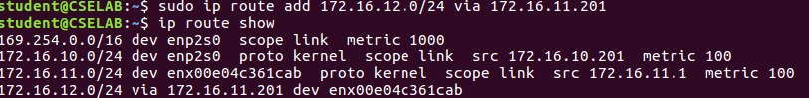

**At R2:**

Sudo ip route add 172.16.10.0/24 via 172.16.11.1

Ip route show

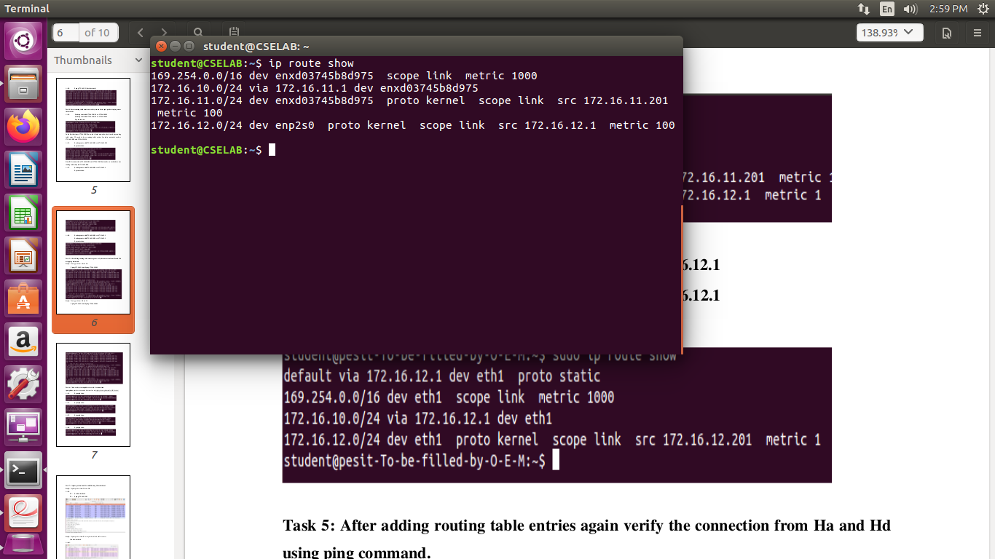

**At Hd:**

Sudo ip route add 172.16.10.0/24 via 172.16.12.1

Sudo ip route add 172.16.11.0/24 via 172.16.12.1

Ip route show



**Task 5: After adding routing table entries again verify the connection from Ha and Hd using ping command**

**Step 1 : testing path from Ha and Hd**

Ping 172.16.12.1 and ping 172.16.12.201

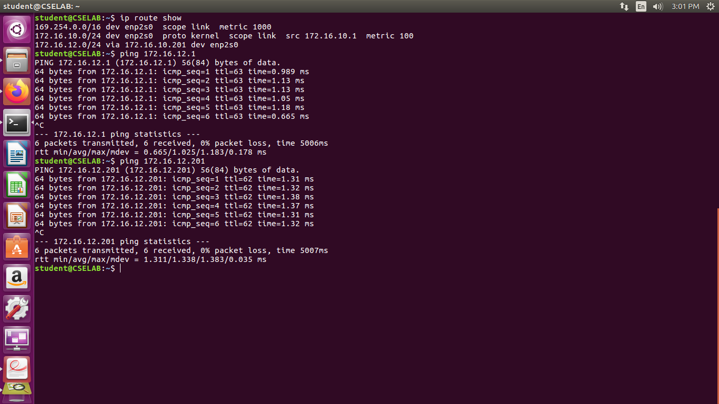

**Step 2: Testing path from Hd and Ha**

Ping 172.16.10.1 and ping 172.16.10.201

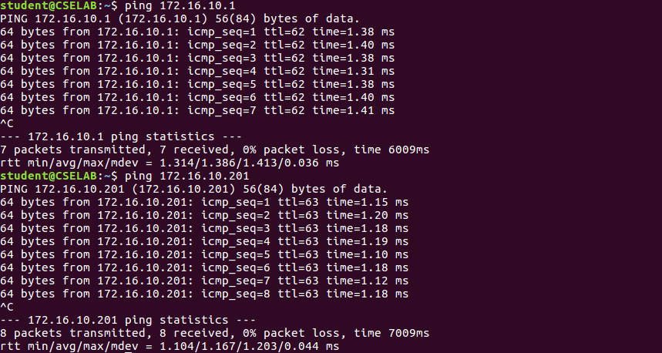

**Task 6: check each system neighbour to verify the connection**

At Ha: ip neigh show

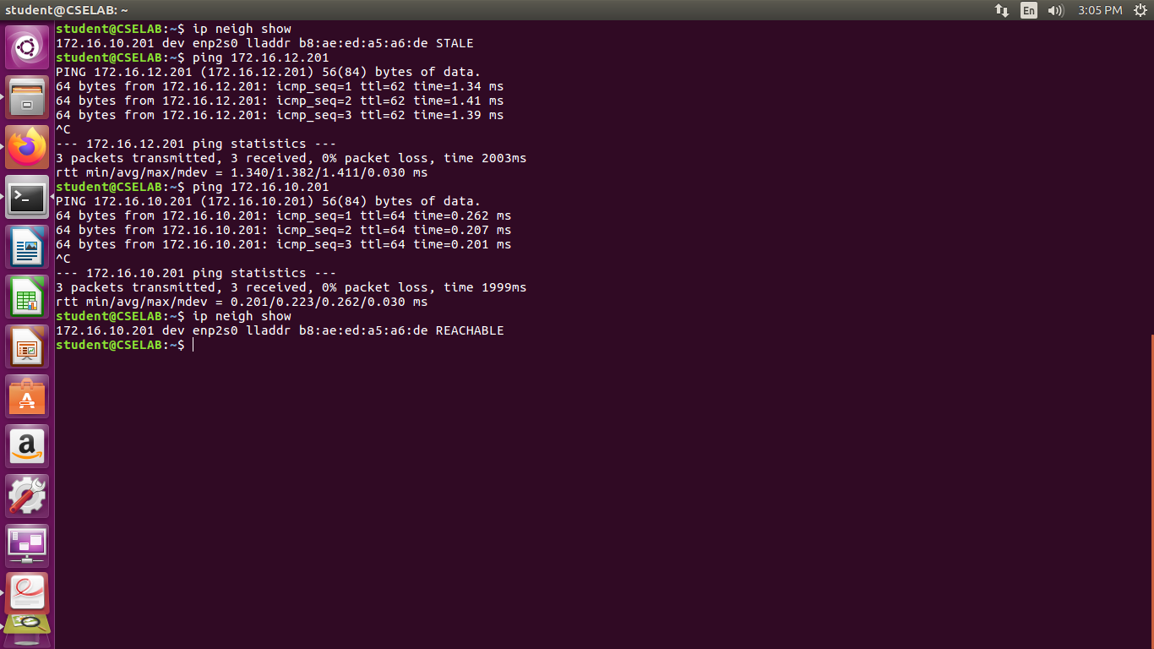

At R1: ip neigh show

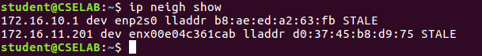

At R2: ip neigh show

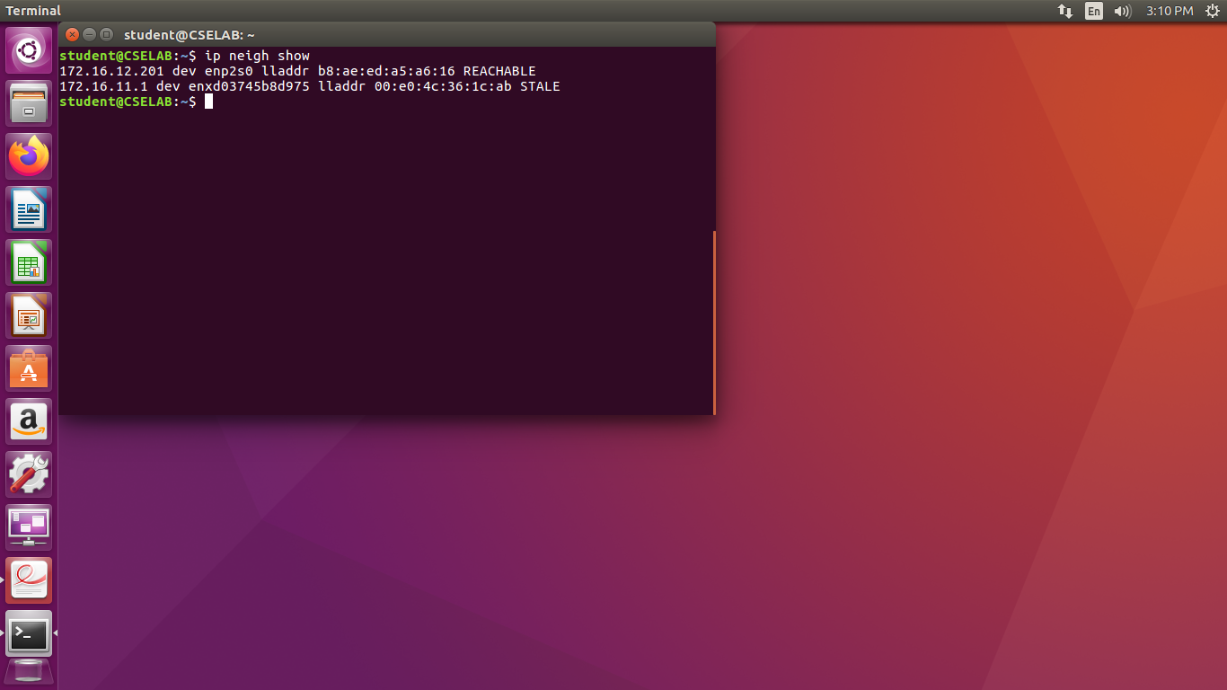

At Hd: ip neigh show



**Task 7: Capture the packets from Ha and Hd using wireshark tool**

**Step1: capture packets from Ha and Hd**

At Ha:

T1: sudo wireshark

T2: ping 172.16.12.201

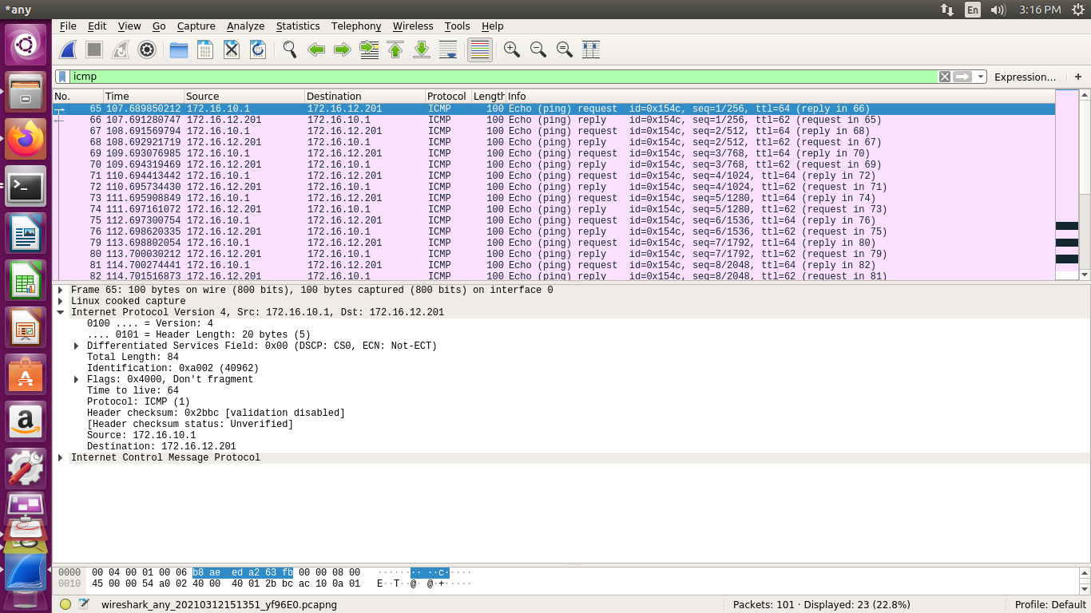

**Step 2: Capture packets from R1 using both eth1 and eth2 interfaces.**

Sudo wireshark

At eth1:

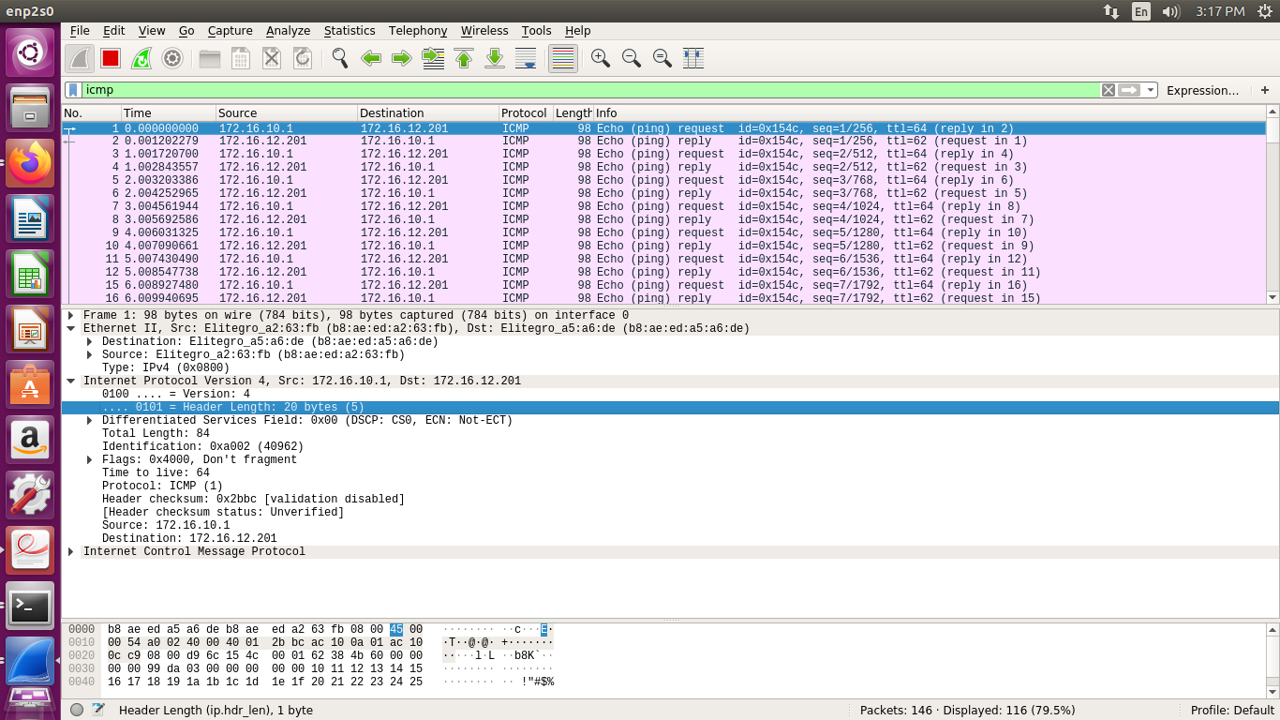

At eth2:

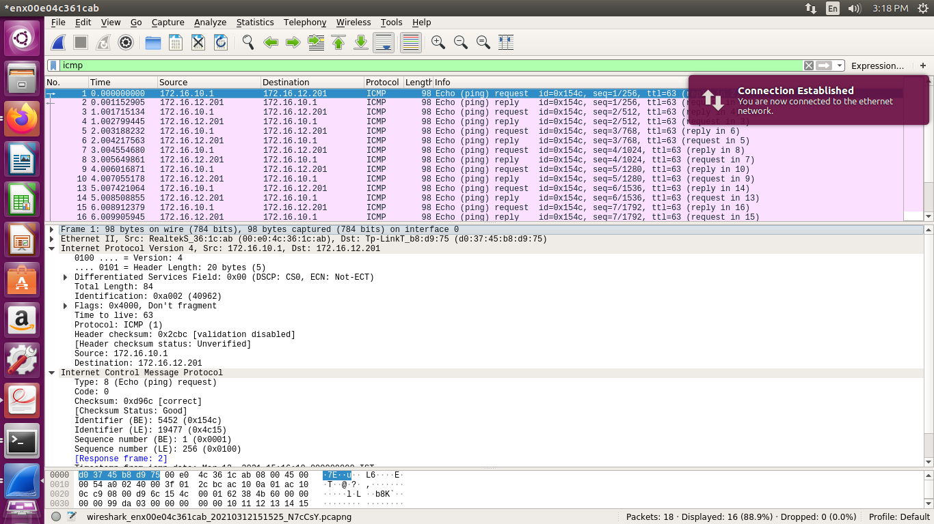

**Step 3: Capture packets from R2 using both eth1 and eth2 interfaces.**

Sudo wireshark

At eth1:

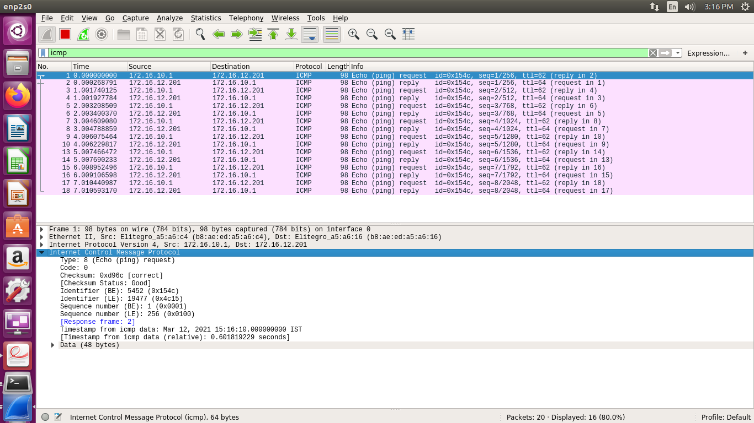

At eth2:

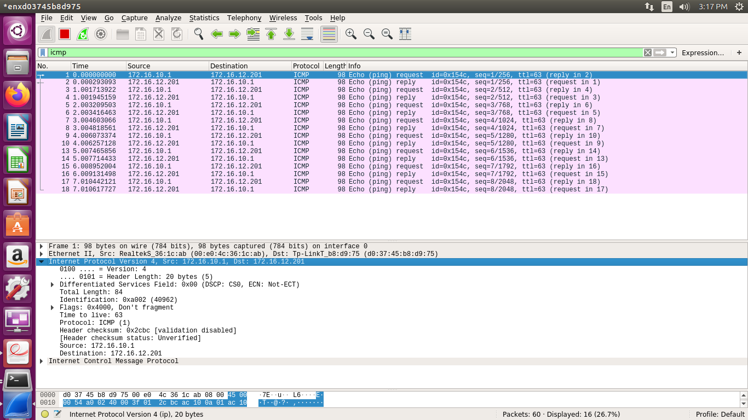

**Step 4: Capture packets from Hd and Ha**

At Hd:

T1: sudo wirehark

